PURPOSE

This document was prepared according to the item 4, paragraph c of the Article 9 entitled the Duties of Occupational Safety Specialists in the Regulation on the Duties, Authorizations, Responsibilities and Trainings of Occupational Safety Specialists.

The working permit procedure is applied in connection with the painting, welding, cleaning, maintenance, repair, carpentry, installation, road marks work, repairs, construction works, assembly, excavation, excavation, etc. to be provided by the external companies serving Safiport Derince Port as well as the works that require hot work on the ships docked, in special operations, in enclosed areas, in risky maintenance works and in the risky works of port personnel.

The purpose of this procedure is to provide a safe working environment for the companies that will work at Safiport Derince Port and to monitor that they fulfill their legal obligations, and to inform the relevant people and ensure that the necessary measures are taken so that the port operations are not affected by the work to be conducted.

SCOPE

This procedure will be applied to all tenants and subcontractors within all fields of activities of Safiport Derine Port.

RESPONSIBLE PARTIES

Safiport International Port Management, Tugboat and Pilotage Services, subcontractors, customers, visitors, solution partners and tenants.

DEFINITIONS

- APPLICATION

- DEPARTMENT REQUESTING THE WORK: The work to be conducted is notified to the Purchasing Department.

PURCHASING DEPARTMENT: After the company that will conduct the work is selected, the purchasing department notifies the occupational safety department while awarding the work and signing the contract.

- DEPARTMENT REQUESTING THE WORK: Directs the company officers to the occupational safety department before the work is initiated.

- OCCUPATIONAL SAFETY DEPARTMENT: Requests the relevant documents from the company that will conduct the work.

THE COMPANY THAT WILL CONDUCT THE WORK:
  - The company that will conduct the work prepares the necessary documents and sends the documents to the Occupational Safety department through e-mail or by hand before the work is initiated.
  - Also, permission is obtained from the Customs Office for the works to be conducted within the port area. The permission is delivered to the customs officers at the Port Main entrance and the Occupational Safety Department.

  - Prior to conducting the Work; the name of the work, area, date range, name and surname of the personnel, machinery and equipment to be used and the vehicle plate registration numbers will be written, sealed and signed on the company's letterhead by indicating the name and surname and delivered to the Occupational Safety and Security Department by e-mail or by hand.
  - For the hot works to be conducted on the ship, the printed form is filled and sent to the Occupational Safety Department.

  - OCCUPATIONAL SAFETY DEPARTMENT: Notifies the company that possesses all documents to obtain a working permit, sends it to the requesting department and directs them to complete a working permit form.

  - DEPARTMENT REQUESTING THE WORK: The department requesting the work completes the working permit together with the company that will conduct the work, and the both signs the form and directs the company to obtain permission from the supervisor of the department where the work will be conducted. For weekend works, permission is obtained in Friday.

  - MANAGER OF THE UNIT IN THE AREA WHERE THE WORK IS CONDUCTED: Notifies that the work will be conducted in the responsible area and signs the working permit if it does not cause any obstacles in terms of occupational safety and the work. Directs it to the Occupational Safety Department.

  - OCCUPATIONAL SAFETY DEPARTMENT: If the documents of the company to be assigned have been fully received, it signs the working permit form.

Depending upon the nature of the work, it also gives permissions for excavation, works in enclosed areas and hot works.
Signs an occupational safety protocol with the company. The port hands over the occupational safety rules to the company. Directs the company to forward a copy of the form to the Security Department.

SECURITY: Directs the company that does not have a working permit or has an expired working permit to the relevant department. Does not allow the personnel not named in the working permit to enter the port.

Document Distribution
White copy: Occupational Safety Specialist
Blue copy: Chief of Operations/Department that assigns the work
Pink copy: The company that will conduct the work
Yellow copy: Security Unit

RELEVANT DOCUMENTS

  - List of documents requested from companies
THE DOCUMENTS TO BE PREPARED BEFORE THE WORK TO BE CONDUCTED AT THE PORT BY THE COMPANIES THAT PROVIDE EXTERNAL SERVICES AT SAFI DERİNCE PORT

The companies that will conduct works at Safi Derince Port (painting, carpentry, plumbing, road marks work, repairs, construction works, assembly, etc.) will not be allowed to work without the following documents.

If the work will be conducted on the own equipment of the ship (such as ship oven, electrical equipment, radar, transformer, painting works etc.) and the work has been assigned by the master, then there is no need for a working permit from us. The agency is required obtain a working permit from the port authority and customs office.

Approval is required to be obtained from the Customs Office for the permission by preparing a petition.
Approval is required to be obtained from the port authority for hot working permit.

1. For the works that last more than one month, a permanent port entry card must be issued from Kocaeli Governor's Office for each personnel and vehicle.
2. Social Insurance employment notice, service breakdown (Human Resources may not employ any person without insurance according to the Social Insurance Law No 5510).
3. Criminal record, (Human Resources)
4. Copy of ID card (Required by the security department to print access cards for permanent contractors.)
5. Blood group card (It may take hours to obtain this information from the company, because blood may be needed in case of occurrence of any accident. Therefore, we keep blood group card in the file of the person, we do not want the blood group card if it is mentioned in the health report or driver's license.)
6. Health report signed and sealed by a doctor to work at heights and to work at nights. Appendix-2 health report approved by the workplace physician. (There is an Administrative Fine in the amount of 2.342 TRY for each employee.)
7. Basic Occupational Safety Training. (According to the Occupational Safety Law No 6331, article 17 and the regulation regarding the procedures and principles of the occupational health and safety training of the employees, it is not appropriate to employ the personnel that do not have occupational safety training. There is an administrative fine in the amount of 948 TRY for each person according to the Occupational Safety Law No 6331).
8. Vocational training certificate for the personnel employed in the works that require Vocational Training (such as forklift, crane operator, welder certificate etc.) - According to the regulation regarding the vocational trainings of those that will be employed in dangerous and very dangerous works; Article 5: It is mandatory to provide employees with vocational training prior to employment. If there is an operator's license and a driver's license issued by the Ministry of National Education or the institutions authorized by the Ministry of National Education, it is valid instead of a vocational training certificate. (There is an Administrative Fine in the amount of 948 TRY for each employee.)
9. Risk Assessment According to the Occupational Health and Safety Risk Assessment Regulation dated 29.12.2012, the employer conducts or gets a risk assessment conducted in terms of occupational health and safety to ensure, maintain and improve the health and safety of the working environment and its employees. (There is an administrative fine in the amount of 21.120 TRY for Dangerous works and 31,680 TRY for Very Dangerous works)
10. Personal Protective Equipment Debit Form: According to the regulation regarding the use of Personal Protective Equipment in the workplace: If the risks in the workplace may not be prevented or sufficiently reduced, personal protective equipment is used, and the debit forms are signed by the employees as a proof of receipt of such equipment.
11. 2 passport size photos (The security department must ensure that access cards are issued for permanent contractors).
12. If a number has not been obtained from the Social Security Institution under the name of Safiport, a temporary assignment letter is required.
13. Periodic control certificate and driver's certificate are required if there is any Heavy Construction Equipment according to the Highways Traffic Law and the Regulation on Health and safety conditions in the use of Working Equipment.
14. A sealed and signed petition is prepared, which includes the ID numbers and names of the personnel, equipment, list of machines, list of vehicle plate registration numbers, work to be conducted and date range.

According to the Occupational Safety Law No 6331, it is mandatory to have and conclude a contract with an Occupational Safety Specialist and a Workplace Physician. (There is an administrative fine in the amount of 19.148 TRY for Dangerous works and 28.722 TRY for Very Dangerous works).

6.2. Working Permit Form
-It is kept by the Occupational Safety Specialist.
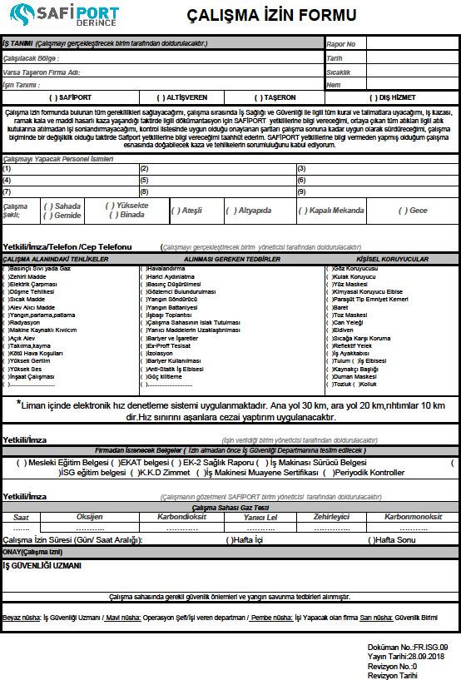

  - Working Permit System Workflow

DEPARTMENT REQUESTING THE WORK | The work to be conducted is notified to the purchasing department/relevant department.
PURCHASING/ RELEVANT DEPARTMENT | After the company that will conduct the work is selected, the purchasing/relevant department notifies the occupational safety department while awarding the work and signing the contract.
OCCUPATIONAL SAFETY DEPARTMENT | Requests the relevant documents from the company that will conduct the work.
THE COMPANY THAT WILL CONDUCT THE WORK | The company that will conduct the work prepares the necessary documents and sends the documents to the Occupational Safety department through e-mail or by hand before the work is initiated.
OCCUPATIONAL SAFETY DEPARTMENT | Notifies the company that possesses all documents to obtain a working permit, sends it to the requesting department and directs them to complete a working permit form.
DEPARTMENT REQUESTING THE WORK | The department requesting the work completes the working permit together with the company that will conduct the work, and the both signs the form and directs the company to obtain permission from the supervisor of the department where the work will be conducted. For weekend works, permission is obtained in Friday.
MANAGER OF THE UNIT IN THE AREA WHERE THE WORK IS CONDUCTED | Notifies that the work will be conducted in the responsible area and signs the working permit if it does not cause any obstacles in terms of occupational safety and the work. Directs it to the Occupational Safety Department.
OCCUPATIONAL SAFETY DEPARTMENT | If the documents of the company to be assigned have been fully received, it signs the working permit form. Directs the company to forward a copy of the form to the Security Department.
SECURITY | Directs the company that does not have a working permit or has an expired working permit to the relevant department. Does not allow the personnel not named in the working permit to enter the port.
  - Hot Working Permit Form
  - Enclosed Area Working Permit Form
  - Excavation Working Permit Form

APPENDIXES

Occupational Health and Safety Protocol and the Companies that Signed Them.

